27-JUL-2007: Ocuco Group files Financial Results
Ocuco Group, comprising Practice Management Software specialists Ocuco Limited, OcucoRelcon and Lab Software business DRS Computing, has just filed financial results for the year ending 31st August 2006.

Total company income was up 4% to £2.8m (€4.2m). Profit fell 30% to £384,048 (€573,206) due to a substantial increase in Research and Development. Only one month’s accounts of now merged Relcon Software Limited accounts are included in the figures, these would bring total revenues for the group in the period to over £4m (€5.7m).
In market share terms the Group made substantial progress, with the total number of supported practices growing over 300% from 326 to over 1,000, representing more than 6,000 desktops using the Acuitas and Focus Practice Management Software across the UK and Ireland.
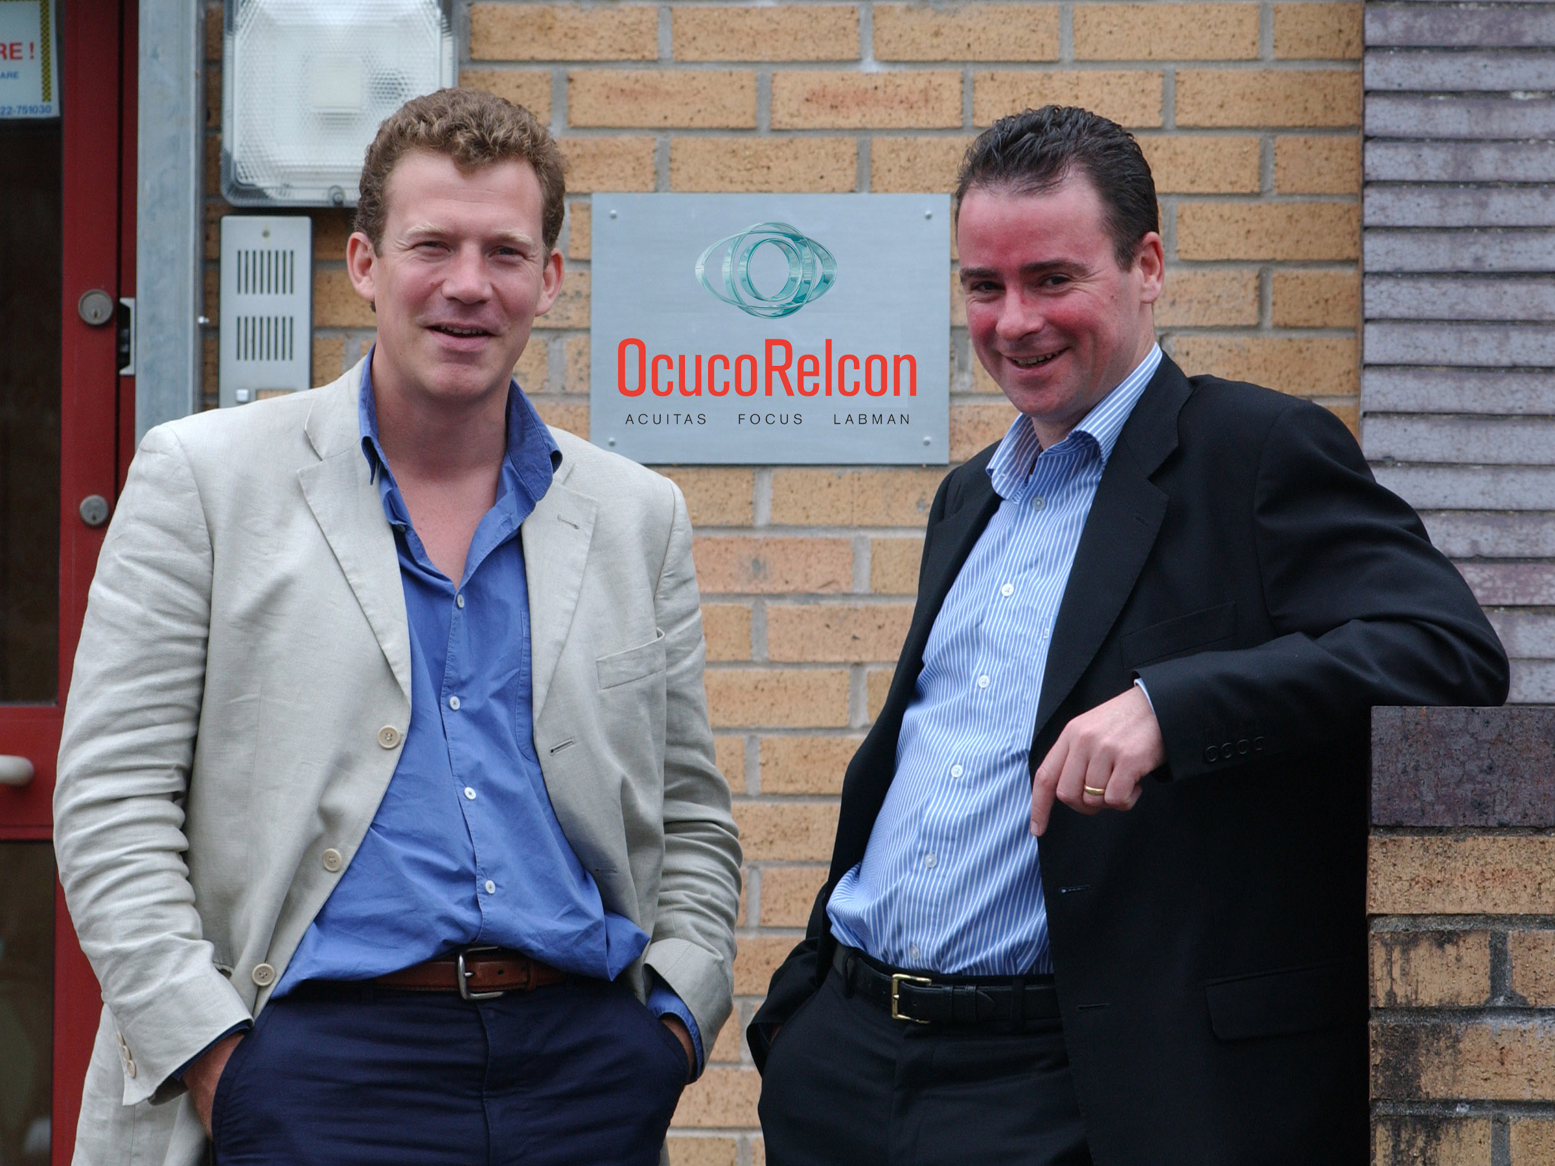

"We are delighted with these results. I put it down to all of our staff who have worked tirelessly to put customers first. We have a strong development pipeline which we hope will drive further growth over the next 12 months." Says Leo MacCanna CEO of the Ocuco Group.
"These results underline the reasons behind our merger, which is about having the scale to be able to offer customers the best possible products and services in partnership with our industry peers", adds Al Chetwode, Chief Executive of OcucoRelcon.

About OcucoRelcon
OcucoRelcon, which has offices in Dublin, Cardiff and Oxford, was formed by a merger of Ocuco’s UK and Irish software divisions and Relcon Software in August 2006.
OcucoRelcon provides patient relationship management software solutions – Acuitas and Focus - to more than 1,000 independent practices, medium sized groups and large chains, and OcucoRelcon is a market leader in the UK and Irish optical market and has the largest optical software development, delivery and support infrastructure in Europe.
DRS Computing, the optical laboratory software division of OcucoRelcon, provides the market leading integrated ophthalmic laboratory management system Labman, used in some of the largest and most sophisticated prescription labs and glazing workshops across the UK and continental Europe. OcucoRelcon’s full complement of software for the optical supply chain provides a unique platform on which to build partnerships in the online ordering space.

About the Ocuco Group
Founded in Dublin in 1993, by Group CEO, Leo Mac Canna, Ocuco is a pioneer of software solutions for the ophthalmic and pharmacy markets. The company’s international launch in 1999 brought revenues to €1.5m, growing to €6m in 2007 with further growth envisaged with international expansion.
Leo Mac Canna completed an MBO in 2005, valuing the company at €5m and, following the merger with Relcon, a highly successful share distribution scheme was taken up by the majority of staff and management.
Ocuco’s strength is its ability to integrate clinical and retail, the application of leading edge technology and strong industry knowledge, accompanied by high levels of support and service.
Ocuco customers include independent and chains of High Street opticians and pharmacies, optical labs, private ophthalmology clinics, hospitals, eye A&E departments.
http://www.ocucorelcon.com/

